Town and Country Planning, England
The Neighbourhood Planning (General Regulations) 2012
Application is hereby made to London Borough of Hackney as the Local Planning Authority for the designation of (1) a Neighbourhood Area and (2) a Neighbourhood Forum in accordance with the above Regulations.
- Application for designation of a Neighbourhood Area (Regulation 5)
  - A map which identifies the area to which the Application relates is included in appendix one (Regulation 5a).
- Statement explaining why this area is considered appropriate to be designated as a Neighbourhood Area (Regulation 5b):
  - The proposed neighbourhood plan area covers the Chatsworth Road Area; from Homerton Road in the south, to Lea Bridge Road in the north, Lower Clapton Road to the east and the Lee Canal to the west, with Chatsworth Road forming a central part of the area and which forms the identity of the proposed Neighbourhood area. The entire area is located within the London Borough of Hackney and falls within Leabridge, Kings Park and Chatham wards.
  - Appropriate collaborative working between members of the forum and wider members of the community has been on going since January 2011. An extensive amount of consultation and research has been undertaken, a summary of the outcomes of such work is attached in appendix five.
  - The area is appropriate for designation; it is a clearly defined area with Chatsworth Road, the local ‘neighbourhoods’ high street running through the centre. The area reflects the functional catchment of the retail/community hub located on Chatsworth Road; the chosen Neighbourhood Area is located entirely within approximately ten minutes walking distance to the chosen Chatsworth neighbourhood centre. The area also includes a population of approximately 10,000 people which is an appropriate quantity to support basic local neighbourhood services and is seen as spatially sufficient for a Neighbourhood Area designation.
  - Following the extensive amount of work which as stated has been carried out and on-going since January 2011, key aspirations for the area have been established and it has been agreed collectively that in order to achieve such objectives work should be continued by producing a Neighbourhood Plan for the proposed Neighbourhood Area. This would mean that such a plan would truly reflect the wishes of the community and a Forum that would include a wide range of community members with different view points on all aspects the Plan will cover.
  - No part of the Neighbourhood Area proposed overlaps any part of any other Neighbourhood Area (Section 61G(7) of the Act).

- Statement that the organisation or body making the area application is a relevant body for the purposes of section 61G of the 1990 Town & Country Planning Act (Regulation 5c):
  - The network of residents and businesses within the Chatsworth Road Area have worked together for many years within other community bodies such as Chatsworth Road Business and Residents Association.
  - Neighbourhood Forum members met at a meeting on 17th September 2011, where it was agreed that that a formal Neighbourhood Forum should be established with the purpose to prepare a Neighbourhood Development Plan in order to deliver and achieve the established, shared key objectives for the area.
  - The Forum has operated successfully on an interim basis since September 2011 and its members represent a cross section of the local community, both in terms of demographics and geographically (refer to appendices three and four).
  - In particular the matrix and information set out in appendix four demonstrates that as part of the background work undertaken and work undertaken to initially set up and agree a forum, the group has targeted a cross section of the community which generally represents the local demographics of the proposed neighbourhood area, which consists of 3 separate local council wards.
  - At this stage that the current, initial forum members represents a good cross section of the local Chatsworth Area community in terms of demographic trend and every effort has been made to encourage all sections of the local community to join; however, as the Neighbourhood Plan and work is taken forward the Forum will endeavour to continue to try and engage with Chinese, Hindu and Sikh communities and encourage them to also join the Forum.
  - Notwithstanding the above, the proposed Neighbourhood Forum will prepare a consultation strategy which will target all community members and be inclusive to everyone. The highlighted gaps as shown in appendix four will be particularly targeted during consultation. It is proposed that a draft of the consultation strategy will be submitted to the Council for their agreement prior to any consultation activity. Although not required by statutory planning regulations, the consultation strategy will be submitted to the Council to satisfy Hackney Council requirements. It is also intended that the consultation on the draft plan undertaken by the Neighbourhood Forum will be carried for 8 weeks (2 weeks longer than required statutorily) in line with provisions set out in Hackney Council’s Statements of Community Involvement (SCI).
  - In addition to the above, no part of the specified Neighbourhood Area consists of or includes the whole or any part of the area of a parish council (Section 61G(3b) of the Act.
  - This application is submitted by Euan Mills on behalf of the Forum as a relevant body (Section 61G(2b)).

- Application for designation of a Neighbourhood Forum (Regulation 8)
  - The name of the proposed Neighbourhood Forum (Regulation 8a) is:
‘Chatsworth Road Neighbourhood Forum’ (CRNF)
  - The written constitution of the proposed Neighbourhood Forum (Regulation 8b) is attached at appendix two to this application.
  - The name of the proposed Neighbourhood Area to which this Application relates is ‘Chatsworth Road Neighbourhood Area’ and the Map which identifies the area is attached at appendix one (Regulation 8c).
  - Contact details of members of the proposed Neighbourhood Forum (at least 1) are (Regulation 8d):
Euan Mills
Email: Euan.Mills@gmail.com
Telephone: 07990555918
Address: 9b Dunlace Road, E5 0NE
  - Statement explaining how the proposed Neighbourhood Forum meets the conditions contained in Section 61F(5) of the Act (Regulation 8e)
(a) the constitution of the Forum proposed (appendix two) and each of the
Forum members have the express purpose of promoting or improving the
social, economic and environmental well being of the proposed Neighbourhood Area
(Section 61F(5)a);
(b) membership is open to (Section 61F(5)b)–
(i) individuals who live in the proposed neighbourhood area,
(ii) individuals who work (whether for businesses carried on there or
otherwise) in the neighbourhood area, and
(iii) individuals who are elected members of the wards which fall
within the neighbourhood area concerned,
(c) membership includes a minimum of 21 individuals each of whom (Section 61F(5)b)
(i) lives in the neighbourhood area concerned,
(ii) works there (whether for a business carried on there or otherwise), or
(iii) is an elected member of London Borough Hackney
(d) it has a written constitution (Section 61F(5)d), and
(e) there are no other conditions that have been prescribed (Section 61F(5)e).
  - Further, the interim Forum has already secured a membership that meets the “desired” criteria of Section 61F(7) of the Act, namely:-
(i) has secured membership that includes more than one individual falling within each of the subparagraphs (i) to (iii) of subsection (5)(b),
(ii) membership drawn from different places in the neighbourhood area proposed and from different sections of the community in that area), and;
(iii) whose purpose reflects (in general terms) the character of that area
  - Refer to appendices three and four and paragraphs 3.6 to 3.6 of this report for full justification of above paragraphs.

Appendix One – Neighbourhood Area Map (as proposed)
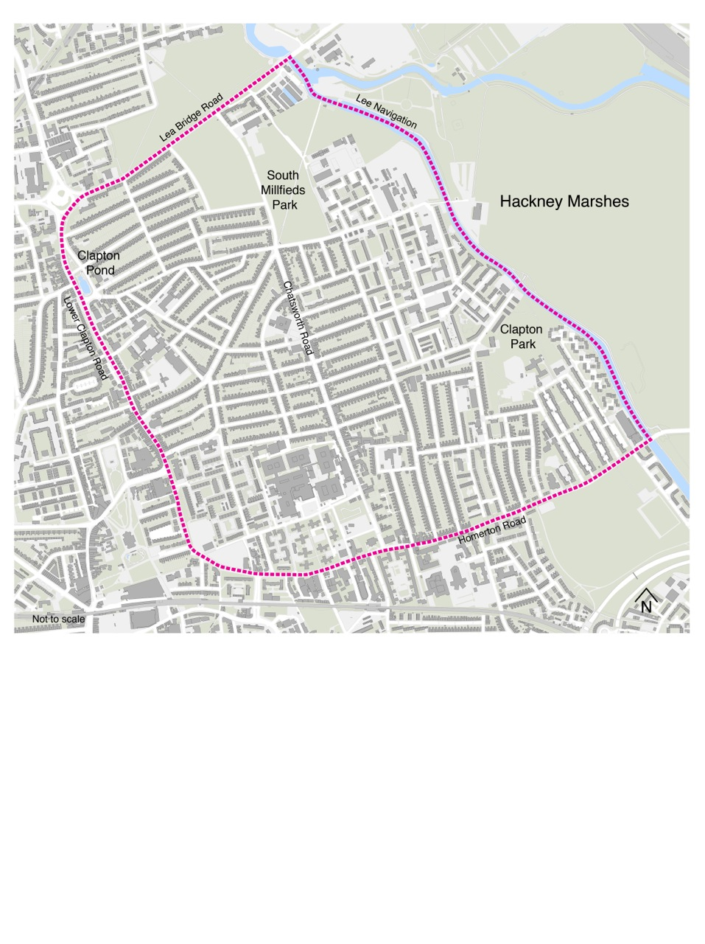

Appendix Two – Constitution (draft submission)

CHATSWORTH ROAD AREA NEIGHBOURHOOD FORUM
CONSTITUTION

- NAME
The name of the Forum shall be the Chatsworth Road Neighbourhood Forum, referred to in the rest of this constitution as the Forum.

- AREA OF BENEFIT

The Forum will pursue its objectives in the area known as The Chatsworth Road Neighbourhood Area for the benefit of the inhabitants of the area including business operators, properly constituted community and voluntary groups and individual residents.

To avoid doubt, this area is the area designated by the Forum for the purpose of the preparation of a Neighbourhood Plan under the Neighbourhood Planning (general regulations) 2012.

- OBJECTIVES
The objectives of the Forum shall be to:

- To prepare in partnership with the local planning authority a neighbourhood plan for the area or in partnership with other forums any wider area.
- to encourage the goodwill and involvement of the wider community in the preparation , production and implementation of a Neighbourhood Plan;
- to express purpose of promoting or improving the social, economic and environmental well being of the proposed Neighbourhood Area

- POWERS

In furtherance of the objects, but not otherwise, the Management Committee of the Forum may exercise the power to:

- Invite and receive contributions and raise funds where appropriate, to finance the work of the Forum, and to open a bank account to manage such funds.
- Publicise and promote the work of the Forum and organise meetings, training courses, events or seminars etc
- Work with groups of a similar nature and exchange information, advice and knowledge with them, including cooperation with other voluntary bodies, charities, statutory and non-statutory organisations
- Employ staff and volunteers (who shall not be members of the Management Committee) as are necessary to conduct activities to meet the objectives
- Take any form of action that is lawful, which is necessary to achieve the objectives of the Forum, including taking out any contracts which it may see fit.
- MEMBERSHIP

Members will apply for membership and the Management Committee shall have the power to accept members.

The Management Committee may refuse membership, or may terminate or suspend the membership of any member by resolution passed at a Management Committee meeting where it is considered membership would be detrimental to the objectives and activities of the Forum.

Membership is open to all who live in the area of benefit of the Forum.

Membership is open to all business operators in the area of benefit of the Forum – Business operators must nominate up to two people in their membership application to exercise one voting right at Forum meetings as set out in clause 6 of this constitution.

Membership is open to all constituted voluntary and community groups which operate in the area of benefit of the Forum. Voluntary and Community groups must nominate up to two people in their membership application to exercise one voting right at Forum meetings as set out in clause 6 constitution.

Membership is open to elected Council members who represent wards in the area of benefit of the Forum.

Membership shall be drawn from different places in the area of benefit and different sections of the community in the area of benefit.
Any member of the Forum may resign his/her membership by providing the Secretary with written notice.

The forum shall have a minimum of 21 members before any decision on neighbourhood planning may be made. The Secretary shall maintain a register of members at all times and publish this online.

6. MEETINGS

- General meetings

All the members of the Forum shall be invited to general meetings at least four times per year.

For general meeting business to be conducted, a quorum of twenty one 21 members must be present at the meeting.

All members shall be given at least fourteen (14) days notice of when a meeting is due to take place

- Annual General Meetings/Special meetings

One of the general meetings of the forum held shall be its annual general meeting (AGM) where the management committee will be elected and a report of activities in relation to each of the Forums objectives by the Chairperson and a statement of income and expenditure will be presented by the Treasurer.

For AGM business to be conducted, a quorum of at least 50% of the membership must be present at the meeting.

All members are entitled to vote at the AGM. Voting shall be made by a show of hands on a majority basis. In the case of a tied vote, the Chairperson or an appointed deputy shall make the final decision.

All members shall be given at least twenty eight (28) days’ notice of when a meeting is due to take place by either e mail or text and all meetings will be publicised on the Forum web site and via notices posted in Homerton Library, Chats Palace , Nye Bevan Community Hall and Wally Foster Community Centre.

Special Meetings may be called from time to time by the Management Committee solely to consider amendments to the constitution or dissolution of the Forum. These shall be subject to the same rules as for conduct of Annual General Meetings.

- Management Committee Meetings

The Management Committee shall meet at least 6 (six) times a year. Meetings shall enable the Committee members to discuss actions and monitor progress to date, and to consider future developments.

All members shall be given at least fourteen (14) days’ notice of when a meeting by e mail or telephone, or as otherwise agreed at a meeting of the Management Committee.
Two -thirds of committee members must be present in order for a meeting to take place.

- MANAGEMENT COMMITTEE

The Forum shall be administered by a management committee of no less than five people and no more than fifteen (15), who must be at least 18 years of age.

Members of the Management Committee will be elected for a period of up to one year, but must stand for re-election at the Forum’s AGM.

- OFFICERS OF THE MANAGEMENT COMMITTEE

The Forum Management Committee shall be elected at the inaugural meeting of the Forum and will be re-elected at subsequent Annual General Meetings of the Forum. It will elect officers consisting of:

The Chair- It shall be the responsibility of the Chairperson to chair all meetings or a designated deputy in his/her absence. And to ensure that meetings are held in accordance with the provisions of the Forum constitution.
The Treasurer – It shall be the responsibility of the Treasurer to ensure that the finance provisions of the constitution (see clause X below are) carried out.
The Secretary - It shall be the responsibility of the Secretary to keep a register of members, ensure that minutes are taken of all Management Committee, Special General and Annual General meetings and that the minutes are accessible to all members via the Forum’s website.

- THE FINANCES OF THE FORUM
Any money acquired by the Forum, including donations, contributions and bequests, shall be paid into an account operated by the Management Committee in the name of the Forum .
All funds must be applied to the objectives of the Forum and for no other purpose.
Bank accounts shall be opened in the name of the Forum. Any deeds, cheques etc relating to the Forum’s bank account shall be signed by at least two (2) of the following committee members: Chairperson; Treasurer; Secretary.
Any income/expenditure shall be the responsibility of the Treasurer who will be accountable to ensure funds are utilised effectively and that the Forum stays within budget.

Official accounts shall be maintained, and will be examined annually by an independent accountant who is not a member of the Forum.

An annual financial report shall be presented at the AGM. The Forum’s accounting year shall run from 01 April to 31 March.

- NEIGHBOURHOOD PLANNING

Any decision to undertake, consult on or submit to the local planning authority for approval any neighbourhood Plan shall be subject to a vote at a General meeting of the forum.
All consultation on the Neighbourhood Plan will be subject to all residents and businesses whether members of the forum or not.
The forum shall set up a website to publicise the neighbourhood planning process, record it and seek views of the public.

The management committee shall be delegated to work with the local planning authority and any independent experts and advisors on the neighbourhood plan as they see fit.
At the discretion of the Forum a “Neighbourhood Plan Team” can be delegated the tasks of preparing the Neighbourhood Plan as outlined in 10a) above.

The membership of this team shall be decided by a full meeting of the forum and the team may co-opt members as it sees fit.

- ALTERATION OF THE CONSTITUTION

Any changes to this constitution must be agreed by a majority vote at a special general meeting, called specifically for the purpose under the same conditions that apply to Annual General meetings specified above.

Proposed amendments to this Constitution or dissolution of the forum must be conveyed to the Secretary formally in writing. The Secretary and other officers shall then decide whether to put the proposed amendments to a special general meeting of the Forum for discussion.

- DISSOLUTION

The Forum may be dissolved if deemed necessary by the members in a majority vote at a special meeting. Any assets or remaining funds after debts have been paid shall be
returned to their providers or transferred to local charities or similar groups at the discretion of the Management Committee.

This constitution was adopted at an Inaugural Meeting of the Forum held at___________ on _____________________ by:

Signed: Chairperson
Signed: Treasurer
Signed: Secretary
Signed: Member
Signed: Member

Appendix Three – Location of Forum members
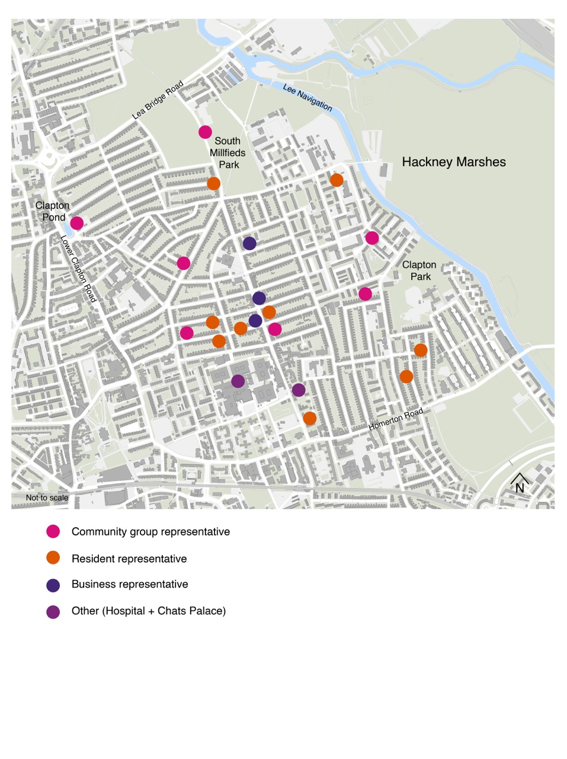
Appendix Four – Demographic breakdown of the Neighbourhood Area and inclusive analysis.
Ward characteristics:
Chatham Ward
Kings Park Ward
Leabridge Ward
 |  | Age | Ethnicity | Religion | Economic Activity
 | Full Characteristic of each ward falling within the Chatsworth Road Neighbourhood Plan Area | - Age profile closely follows Hackney’s; however, it does have relatively fewer 5-17 year olds  - 13.2% aged 16 – 24 (slightly higher than London and borough figures)  - lower % of retired age compared to London and borough  - Higher proportion of children and young people ( 0 – 16) compared to rest of Borough  - More people between 45 and 74  - 14.1% population aged 16 – 24 (slightly higher than London and borough figures)  - lower % of retired age compared to London and Borough figures  - 13.9 % population 16 - 24 (slightly higher than London and borough figures) lower % of retired age compared to London and Borough figures  - Relatively more 30-64 year olds. | - More than 30% of the ward’s population is Black compared to 10.9% London wide.  - higher proportion of Chinese or Other groups than is typical for the borough  - More than 36% of the ward’s population is Black, while just less than 35% is White British, the lowest share in any Hackney ward.  - Higher proportion of Mixed groups than is typical for the borough.  - White people accounted for exactly half the ward’s population  - Almost 20% are Asian, the highest percentage of any Hackney ward.  - A higher proportion of Mixed groups than is typical for the borough.  NB: The proposed Neighbourhood area includes a traveller’s site therefore this group will also need to be targeted. | - higher proportion of Christians than Hackney  - Both its Muslim (14%) and Buddhist (1.6) communities are slightly larger than the average for the borough.  - higher proportions of Christians than Hackney does  - higher proportions of Muslims than Hackney does  - Lower proportions of Christians and Jews than borough figures.  - Muslim, Hindu and Sikh communities are all significantly larger (21% 1.7% and 1.4% respectively) than the average for the borough. | - Less than half the residents between the ages of 16 and 74 are in employment  - larger numbers of students (13.6%)  - Higher proportion of permanently sick or disabled population compared to Hackney and London figures.  - Less than half the residents between the ages of 16 and 74 are in employment - economic inactivity is high.  - Higher proportion of permanently sick or disabled population compared to Hackney and London figures.  - The unemployment rate is above the borough average.
 | Summary of all three wards data | - Young people (under 16)  - People aged 16 – 24  - More people aged between 45 and 74  - More people aged between 30 and 64 | - Higher percentage of Black population  - Higher percentage of Chinese and other population  - Higher amount of Mixed groups  - Higher percentage of Asian population | - Higher percentage of Christians  - Higher Muslim community  - Higher Hindu + Sikhs communities | - Higher proportion of unemployed people  - Higher proportion of Students  - Higher proportion of Sick/disabled
Targeted Groups for membership of Forum and future target for consultation: |  | Analysis of Chatsworth Road Neighbourhood Area Characteristics*
Chatsworth Road TRA |  | AB C D | AB C D | AB C | AB C
All Souls Church |  | unknown | unknown | AB C | unknown
Adventist Church |  | unknown | unknown | AB C | unknown
Salvation Army |  | unknown | unknown | AB C | unknown
Senior Leisure Hour |  | AB C D | unknown | unknown | AB C
Luncheon Club |  | AB C D | unknown | unknown | AB C
Pedro Club |  | AB C D | AB C D | unknown | AB C

Clapton Park TRA |  | AB C D | unknown | unknown | unknown
NYE Bevan TRA |  | AB C D | unknown | unknown | unknown
Banister House and Priory Court TRA |  | AB C D | unknown | unknown | unknown
Jack Dunning TRA |  | AB C D | unknown | unknown | unknown
Millfields User Group |  | AB C D | unknown | unknown | AB C
Friends of Homerton Station |  | AB C D | unknown | unknown | AB C
Clapton Pond Neighbourhood Action Group |  | AB C D | AB C D | unknown | AB C
Clapton Arts Trust |  | AB C D | AB C D | unknown | AB C
Interviews undertaken as (background Chatsworth work)F |  | AB C D | AB C D | unknown | unknown
Members of Forum (as of October 2012) |  | AB C D | AB C D | AB C | AB C
The ward characteristics have been extracted from Hackney Council ward profile data which have are based on 2001 census data. Once updated information and 2011 census data becomes readily available the table will be updated and submitted to the council and will also be made available for all members of the public.

The highlighted text denotes sections of the community not currently specifically represented within targeted groups.

From the above, in summary as the process continues and as part of the consultation strategy the following groups will need to be specifically targeted:
- Young people (16 and under)
- Young Adults (16 – 24)
- Chinese and Asian Groups
- Muslim, Hindu and Sikh communities
- Unemployed
- Disabled groups

Appendix Five – Background Comment

In January 2011 we embarked on a project to identify the common aspirations that local people have for the area. In order to do this we had approximately 300 local residents fill out surveys; we undertook 14 in-depth case study interviews with a hand-picked diverse range of residents; we had 60% of local businesses give their views via a trader specific survey; we met with 14 local community group representatives, including religious groups, tenants organisations and elderly and youth clubs, local councillors and police; and took part in a project with students from the City Academy considering the future of the area.
We consolidated this work and distilled five key aspirations that we believe best reflects local people’s values about the area, these are set out below:
1. Sociable
There is more to a great neighbourhood than just people living in the same area. We want a neighbourhood that has a strong sense of community, a place rich in social capital. A neighbourhood where we recognise people who use the same shops, streets and spaces that we do, where we often bump into people we know, and can go to places where we can meet others who might have the same interests as us.
2. Diverse
We want a neighbourhood defined by its diverse mix of people, rather than any single dominant group. A place where people of all ages, incomes and creeds live and work side by side, where we are exposed to different cultures, tastes and beliefs to our own but still feel at home. A place that is open to incomers but values its longer-term residents. We need to encourage this diversity and nurture shops, provide homes and build workplaces that can serve our diverse community.
3. Accessible
We want to live in a neighbourhood that is easy to get around, whether walking, cycling, driving or in public transport. A place where it is safe and attractive to walk to shops, parks and schools, where the less abled feel they can get around with as much ease as the abled, where you can cycle without feeling intimidated by motor vehicles, but where you can easily drive through to get to go farther afield. We need a neighbourhood with a simple and legible network of streets, where the burden of traffic is shared equally. Streets that can accommodate a variety of users whilst prioritising the most vulnerable.
4. Independent
We want a neighbourhood with a healthy and resilient local economy, a place where money remains in the community and profit is measured not solely in pounds and pence. A place not dependent on any single company for goods, services or employment. A place that supports a diverse range of local small and medium-sized business, and provides a nurturing environment where new businesses can flourish. A place that attracts talented, creative and the entrepreneurial people to live and to work.
5. Sustainable
We want a neighbourhood that uses resources wisely and actively minimises its ecological footprint. A neighbourhood where all waste is recycled or re-used; where walking and cycling are the primary modes of transport; where the energy we consume is produced in a sustainable manner and all buildings use it efficiently; and with places to grow our own food.

